**Task 1.1: Research and list at least five benefits of cloud computing over traditional on-premises infrastructure.**

**Benefits of Cloud computing:**

===========================================================

* Ability to access data anywhere at any time by user.
* **Customer Relationship Management (CRM):** Cloud-based CRM systems enable banks to manage customer data and interactions. They allow financial institutions to keep track of all customer interactions, regardless of location or time of day.
* **Disaster Recovery:**The most significant benefit of transitioning to the cloud is its robust disaster recovery with integrated redundancies. With the financial world moving at a much faster pace, the cloud allows banks to streamline opportunities, meet customer expectations and operate at the speed of business by regaining access to actionable insights in case of disruptive events or natural disasters.
* **Faster Processing Speed:**Cloud platforms offer fast performance since they can handle large amounts of data quickly and easily. It allows banks to improve their transaction processing speeds and reduce latency problems.
* **Centralized Data Repository:**Cloud platforms enable seamless integration of disparate business data and operational systems with secure & easy data sharing. It creates centralized and connected data to drive integrated decisions and solve customer problems more quickly.

**Task 1.2: Describe the Cap Ex and Op Ex models of financing IT infrastructure, providing examples of when each model might be preferred**

**Cap EX (Capital Expenditures):**

Cap Ex is the money an organization spends to either buy or enhance its fixed assets. These assets are long-term investments that will be used over multiple fiscal periods.

This includes physical assets like real estate, machinery, or other equipment.

**Examples**: Purchasing a new building

**Op Ex (Operational Expenditures):**

Op Ex refers to the ongoing costs associated with running a business or a particular system within it. These are the expenses that a company incurs as part of its daily operations.

**Examples**: monthly subscriptions for software, utility bills, and other routine business expenses.

**Task 2.1: Create a brief report differentiating public, private, hybrid clouds. Include a diagram for each cloud.**

## **Public Cloud**

* A Public Cloud is Cloud Computing in which the infrastructure and services are owned and operated by a third-party provider and made available to the public over the internet.
* The public can access and use shared resources, such as servers, storage, and applications and the main thing is you pay for what you used.
* Examples of public cloud providers – are Amazon Web Services (AWS), Microsoft Azure, and Google Cloud Platform (GCP)

### Advantages

* **Cost Efficient**: In the public cloud, we have to pay for what we used. So it is more cost-efficient than maintaining the physical servers or their own infrastructure.
* **Automatic Software Updates**: In the public cloud, there are automatic software updates. we don’t have to update the software manually.
* **Accessibility**: Public clouds allow users to access their resources and applications from anywhere in the world. We just need an internet connection to access it.

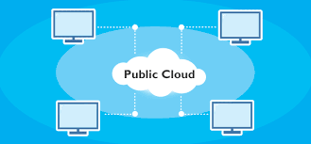

## **Private Cloud**

* A Private Cloud is a cloud computing environment in which the infrastructure and services are owned and operated by a single organization, for example, a company or government, and it is accessed by only authorized users within that organization.
* Private Cloud organizations have their own data center. Private cloud provides a higher level of security.
* Examples – HPE, Dell, VMware, etc.

**Advantages**

* **Security Status**: Private clouds provide a higher level of security. as the organization has full control over the cloud service. They can customize the servers to manage their security.
* **Customization of Service**:  Private clouds allow organizations to customize the infrastructure and services to meet their specific requirements. And can customize the security.
* **Privacy**: Private clouds provide increased privacy as the organization (company or government) has more control over who has access to their data and resources.

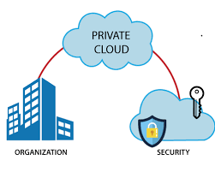

## **Hybrid Cloud**

* Hybrid cloud is a combination of both public and private cloud environments that allows organizations to take advantage of the benefits of both types of clouds.
* It manages traffic levels during peak usage periods. It can provide greater flexibility, scalability, and cost-effectiveness than using a single cloud environment.
* Examples – IBM, Data Core Software, Rack space etc.

### Advantages

* **Flexibility**: Hybrid cloud stores its data (also sensitive) in a private cloud server. While public server provides Flexibility and Scalability.
* **Scalability**: Hybrid cloud Enables organizations to move workloads back and forth between their private and public clouds depending on their needs.
* **Security**: Hybrid cloud controls over highly sensitive data. and it provides high-level security. Also, it takes advantage of the public cloud’s cost savings.

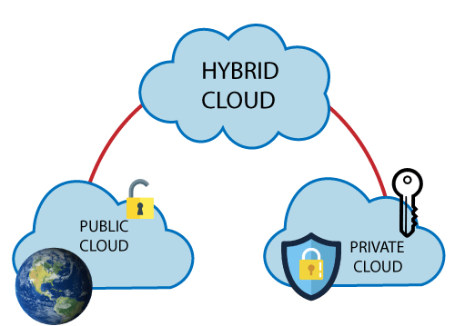

**Task 2.2: For each cloud model, list one real-world application or scenario where that model would be the most appropriate choice.**

Public cloud- Yahoo, Gmail

Private cloud-Google drive

Hybrid cloud- Banking Applications